Aumyr Travel Guide
A guide to the Empire of Aumyr and the kingdoms of the realm

Khoralis
Races – All
Deity – Helm – God of Protection – Holy Site
Imperial Capital of the Empire. Center of all global politics. Most well defended site in all of Aumyr
Institutions – Council of Kings, Royal Guard Academy
Ruler – King Florianus of Faeland

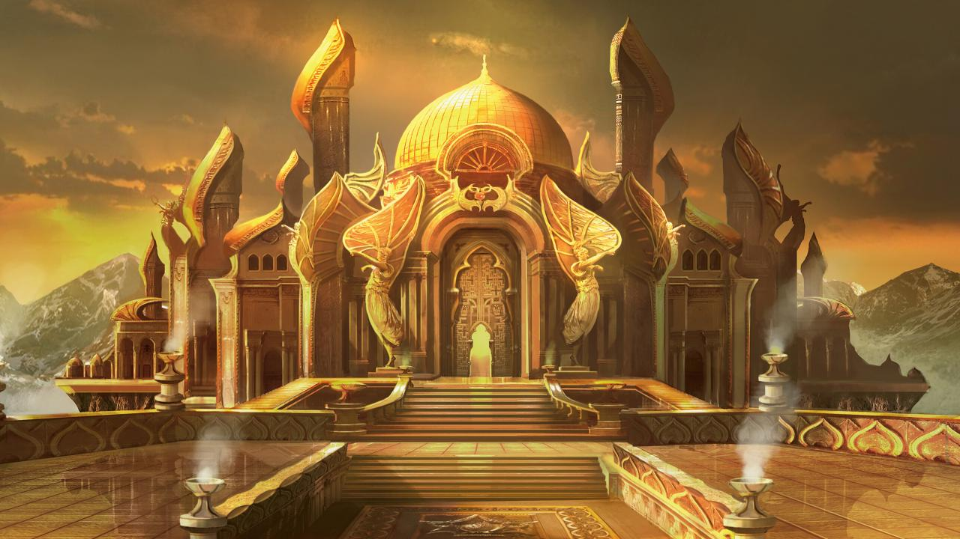

Inkari
Races – Human
Deity – Waukeen – Goddess of Trade – Holy City - Heldar
Eldath – Goddess of Peace – Holy City - Meentum
Bane – God of Tyranny – Holy City - Thymar
Capital – Meentum
The last remaining Human Kingdom after the War of Light and Fire, the kingdom is a mix of Humans of all spaces, sizes, colors and beliefs. The Capital, Meentum, is the first line of defense for the Imperial Capital against almost any invasion. The human politics, which they call “the Dance,” has spawned countless stories, novels and poems to all the moves made by the various houses.
Houses – Underhill, Van Dyke, Dahl, Warfield, Longoria, Garland
(African)(European)(Arabic)(Asian)(Mediterranean)(American)

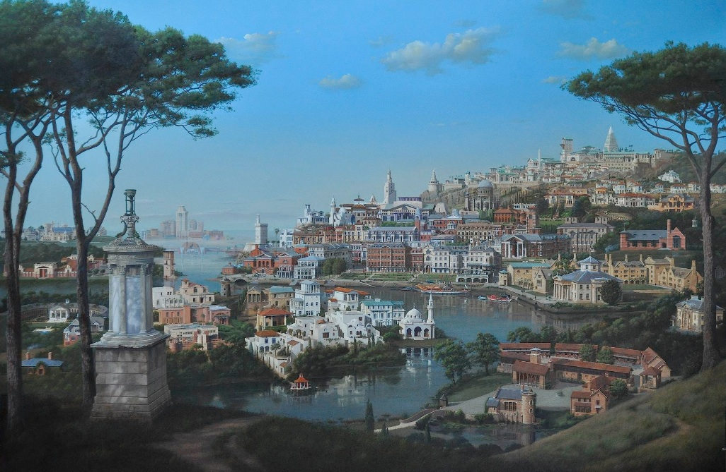
Gwaldur
Races – Dragonkin
Deity – Mystra –Goddess of Magic – Holy City - Kaphnur
Savras – God of Divination and Fate - Holy City - Vardanos
Bahamut – Dragon God of Good - Holy City - Refuge
Tiamat – Dragon Goddess of Evil – Holy City - Zarhia
Capital - Kaphnur
The home of the Dragonkin, this land is with hidden treasures, magic and the bones of their ancestors. The fight to keep those of ill-intent out and those of pure motives in has been very difficult and occasionally running afoul of the royal law, The Right of Trade. The capital of Kaphnur is a marvel of the world, built using dragon bones, blood and magic, its looks over the seas like a towering mountain. It represents who they were, are and could become.
Institutions – Schools of Sorcery
Houses - Rivertide - Blue, Firecrest - Black, Starchaser - Bronze, Wildmount - Gold, Hilldale - Green, Demonskull - Red, Frosthorn – White, Trickwing - Brass
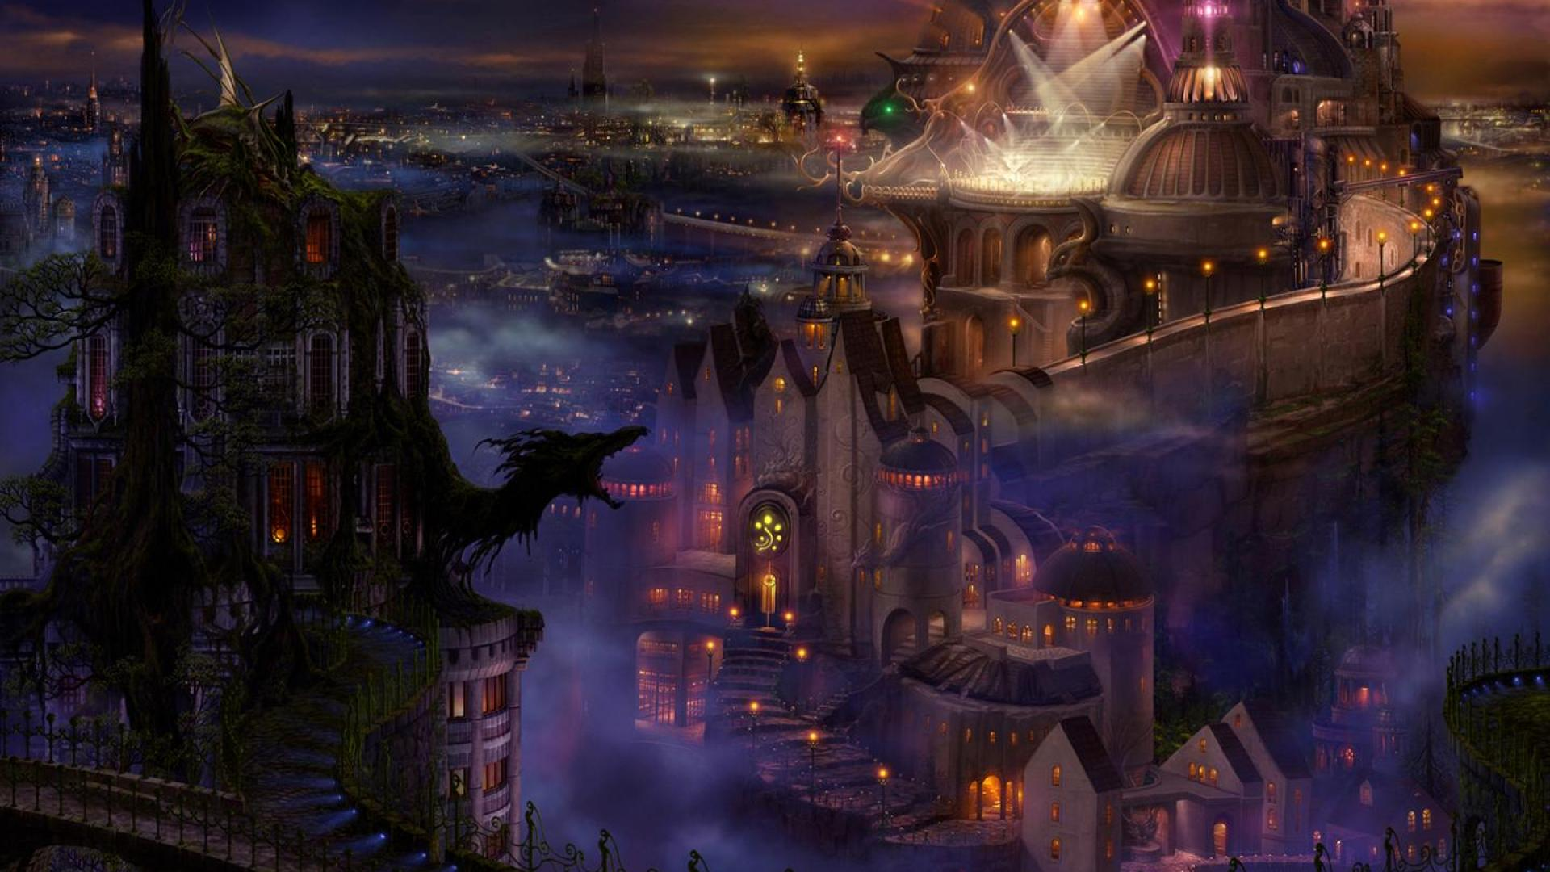

Pendor
Races – All
Deity – Laathander – God of Birth and Renewal – Holy Site
The holy city of the Empire. Temples dedicated to every deity, included the Raven Queen are located within this city. All were constructed by the god, Laathander. The city is ruled by a single religious entity, the Chaosopher, elected by the Council of the Divine. The most holy and devoted flock to the city to prove their faith and to be trained in defending, spreading and learning the faith.
Leader – Chaosopher Publius of the order of Savras

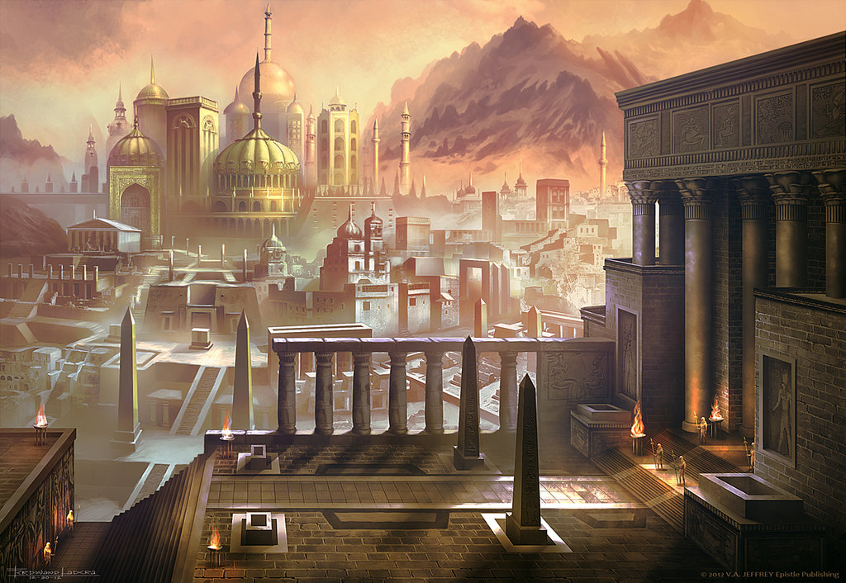

Thanaros
Races – Teifling
Deity – Sune – Goddess of Love and Beauty – Holy City - Viriana
Cyric – God of Lies – Holy City - Omniros
Capital - Viriana
The home of the foreign race from the reaches of various hells, the Teifling were granted this land as part of bargain to side sides in “the War of Light and Fire.” While acting as guardians and researchers of the past, the amount of good land is a rarity. The capital of Viriana is a major trading port for the region. While they abilities are not doubted, their intentions are often questions because of their once hellish past.
Houses – Amarzian – Darkling (Archeology), Shadeven, Romazi – Murkblood, Castle Blackraven, Vadu – Abyssal, Feldun, Menetrain – Infernal, Hellion

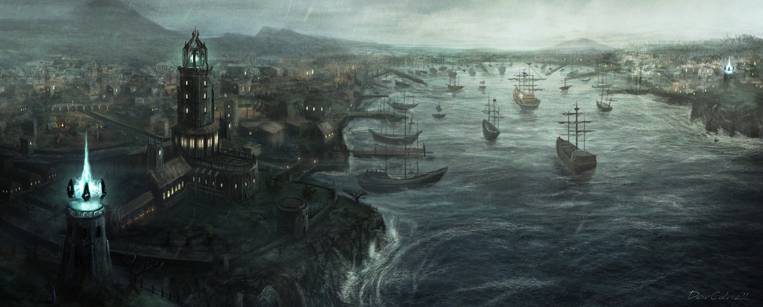

Laendil
Races – Wood Elves/Seedlings
Deity – Silvanus – God of Wild Nature – Holy City - Mistdeep
Mielikki – Goddess of Forest – Holy City - Nayalis
Capital - Nayalis
Institutions – Druid Circles
The home of Nature wielders, the Druid Circles grew out of the understanding of the forces of nature given to the 2 races of the forest. While they share a capital, the two races homes are Mistdeep for the Seedlings and Jademar for the Wood Elves. The capital of Nayalis was built using druidcraft and an understanding of how mortals and nature can live together in peace, the city is high off the ground in the canopy of the forest that bares its name.
House – Elves – Bluerock, Sagevale, Rivergrove
Seedlings – of the Oak, Of the Redwood, of the Pine, of the Palm

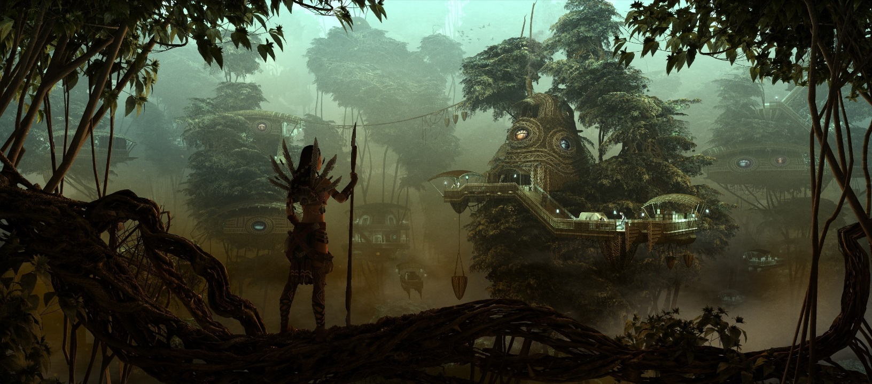

Dreamor
Races – Genasi
Deity – Ilmater – God of Endurance – Holy City - Qadris
Torm – God of Courage and Self-Sacrifice – Holy City - Fivestar
Capital - Fivestar
Institutions – Monk Training Temples
The harsh lands of the Genasi reflect their preferred way of life, one of purpose, testing oneself and understanding the elements that you share with nature. The landscape is ideals for testing the will and nature of a person to their core, especially those dedicated individuals who follow the path of one of the Monk Training Temples.
Houses – Air – Sahash(Open Hand, Gavrin), Earth – Dokrum(Long Death, Qadris), Fire – Ashir(Sun Soul, Fivestar), Water – Uworl(Shadow, Demeriah,), Duel – Ashduryaor(Four Elements, Archbridge)

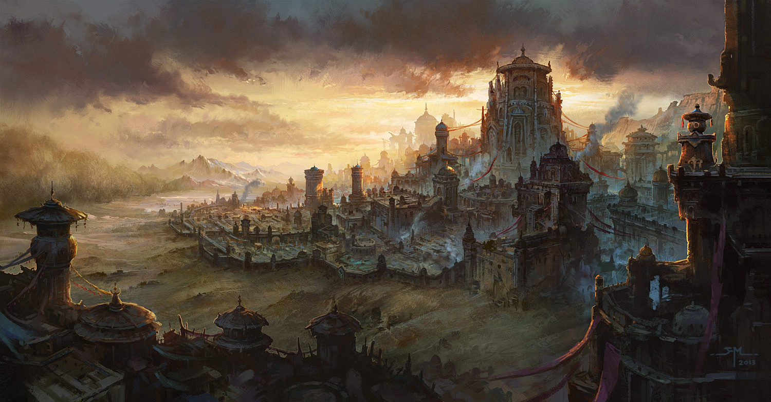

Jhert
Races – Drow
Deity – Shar – Goddess of Darkness and Loss – Holy City - Silverstone
Leira – Goddess of Illusion – Holy City - Pindar
Talona – Goddess of Disease and Poison – Holy City - Molos
Capital - Silverstone
In the land of forever shadow, the questionable Drow have lived with very little contact with outside races, only to talk with other nobles and needed traders. Secrets, plots and treachery seem to be the main pursuits of this shadowy race, both within and outside its borders. It is said that the capital of Silverstone is made out of Whitestone, spider webs and unnaturally large mushrooms. Many other races call this land, the Underdark.
Houses – Do’arn, Gode’ett, Tor’rae, Cladd’Sek, Noqu’rahel

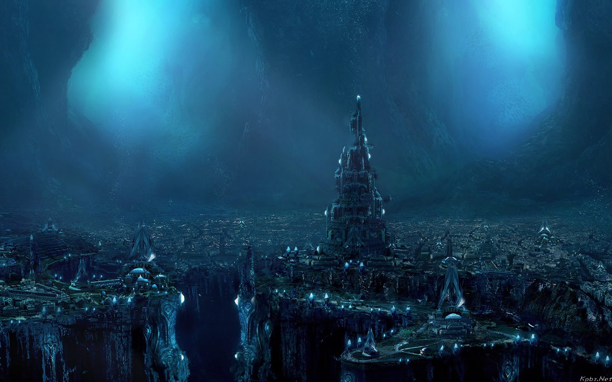

Laangor
Races – All
Deity – Malar – God of the Hunt – Holy City - Hundres
Beshaba – Goddess of Misfortune – Holy City - Highpine
Capital - Highpine
Institutions – Ranger Academy - Greencamp
The history of this kingdom is marked by crime, scandal and despair. Laangor is the land of the outcasts, people who can never go home again. To be sent here, unwillingly, is the 2nd highest form of punishment in all of Aumyr, with death by Hydra being the 1st. The only way back is to become one of the King’s Rangers, where service is for life. The land is run by “the Families.” Former nobles and other “business men” who have regained royal title through various means. The capital Highpine serves both as a waystation for the cast out and a den of all possible vices, legal and illegal.
Houses – Hawklight – Human, Songsteel – ½ races, Diamonddeath – Drawf, Trailtreader – Elves(all), Tumblebelly – All other races

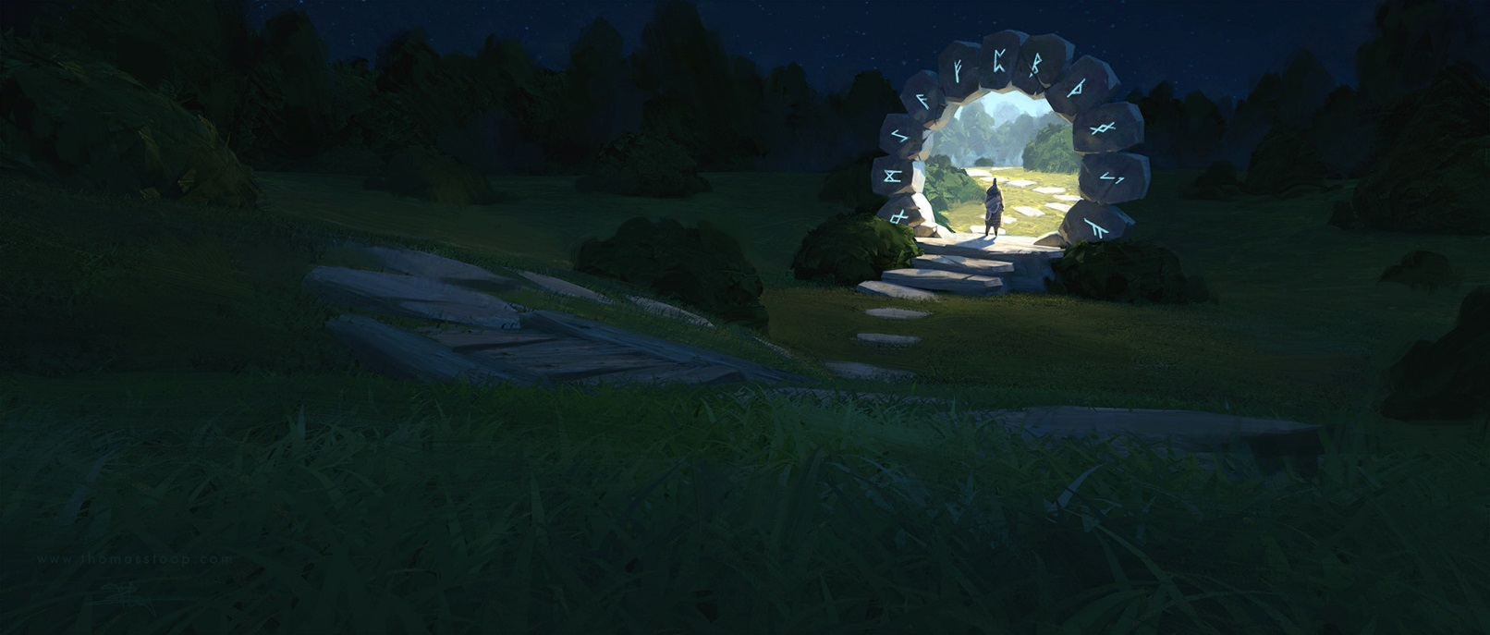
Merosh
Races – Dwarves
Deity – Tyr – God of Justice – Holy City - Searun
Tymora – Goddess of Good Fortune – Holy City - Veloras
Capital - Veloras
Institutions – Imperial Hall of Justice – Searun, Smithers guild and Jewelers Guild - Veloras
The Dwarven kingdom of Merosh is the center for all weapons and armor in the Empire. Their crafting skills are unquestioned and demand is always high for their newest creations. The mines seem to never run out of material, gems and other needed items for people. The wealth from all these works have produced a handmade city inside a now silence volcano that keep the temperature constant all year around. New pieces are added daily to show off each house’s power and wealth. However, all the wealth has also brought in intrigue and discord, especially within the Council of Minerals.
Houses – Hill – Bloodhammer(Military), Mountain – Fistbeard(Judge), Shield – Knucklebreak(Weapons & Armor), Gold – Hammerforge(Jewels & Art), Gray – Shadowrock(Underbelly)
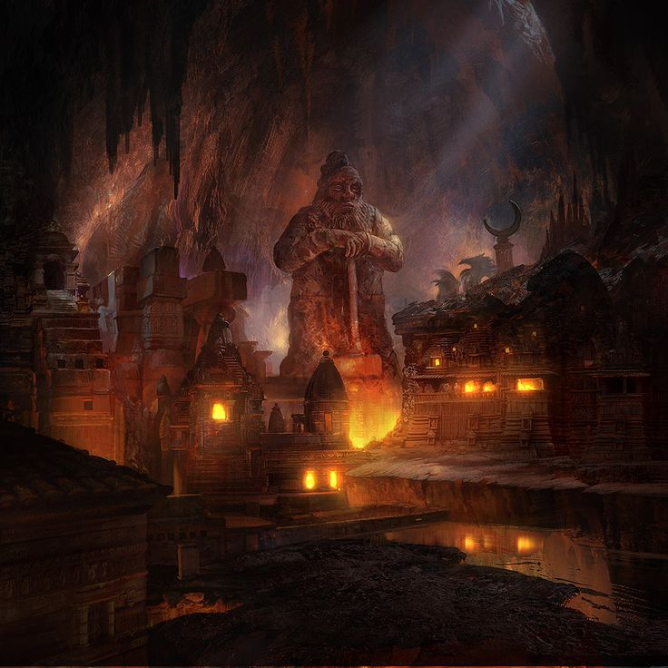
Zeitan
Races – Revenant
Deity – Kelemvor – God of the Dead – Holy City - Nordur
Myrkul – God of Death – Holy City - Deepdelve
Capital - Nordur
Institutions – Warlock Ziggurats, Tombs of the Nobility - Lakeside, Land of the Dead Portal - Morius
The land of the dead has always been a place of mystery and suspicion. With the dead of former nobility coming back and never knowing for sure who will, the leadership of this place is quite unpredictable. The time they were in control of the empire had them install a king who had been a king already on the throne. With that in mind, the Council of Kings decreed the Revenant of the land to be the keepers of the dead and allowed for the study of that realm and others. The various studies built Ziggurats to their specialty and practice their arts quietly. This is also the resting place of all dead nobility. A small town serving the tombs and their bones allowed to be risen after death to serve them eternal.
House – Cult of the Scale - Dragonborn, Village of the Willing – workers, Council of the Damned – Humans, Pact of the Risen – Halflings/Dwarves, Clan of the Forgotten – All other races
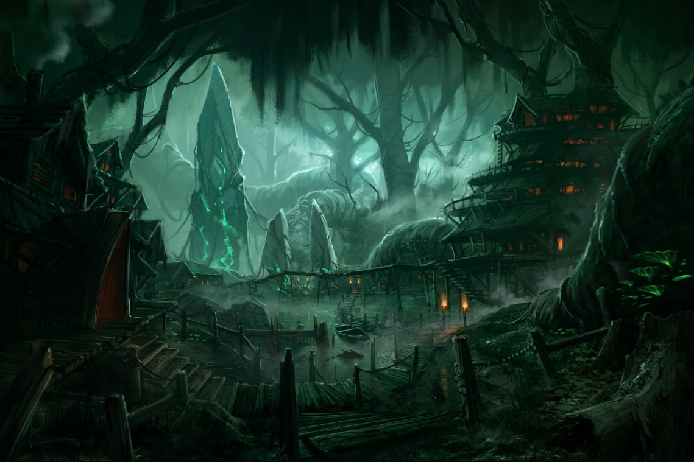
Aumar
Races – Halfling/Catfolk
Deity – Milil – God of Poetry and Song – Holy City – Greatdale
Chauntea – Goddess of Agriculture – Holy City - Atanis
Capital - Atanis
Institutions – Bardic Colleges
The shared land of Aumar is the breadbasket of the empire. With almost 75% of all food grown here, its power comes from filling people’s stomachs and hearts. The many Bardic Colleges fill the kingdom with song and study. The land is filled with the two but completely different races. On the one hard are the hardy and jolly folk of the Halfings, who do most of the farming in this kingdom. While closer to the woods are the secretive Catfolk, while they raise a lot of the livestock for the kingdom, what people know about them is very little. Few leave the herd and even less is known about their Alpha.
House – Halfling – Lightfoot –Trill(Lore), Stout – Millbridge(Sword), Strongheart – Weatherbee(Maestro)
Catfolks – Lion – Panthera(Valor), Tiger - Tigris, Cheetah – Jubatus(Dance), Jaguar – Onca(Performance), House – Felis(Satire)
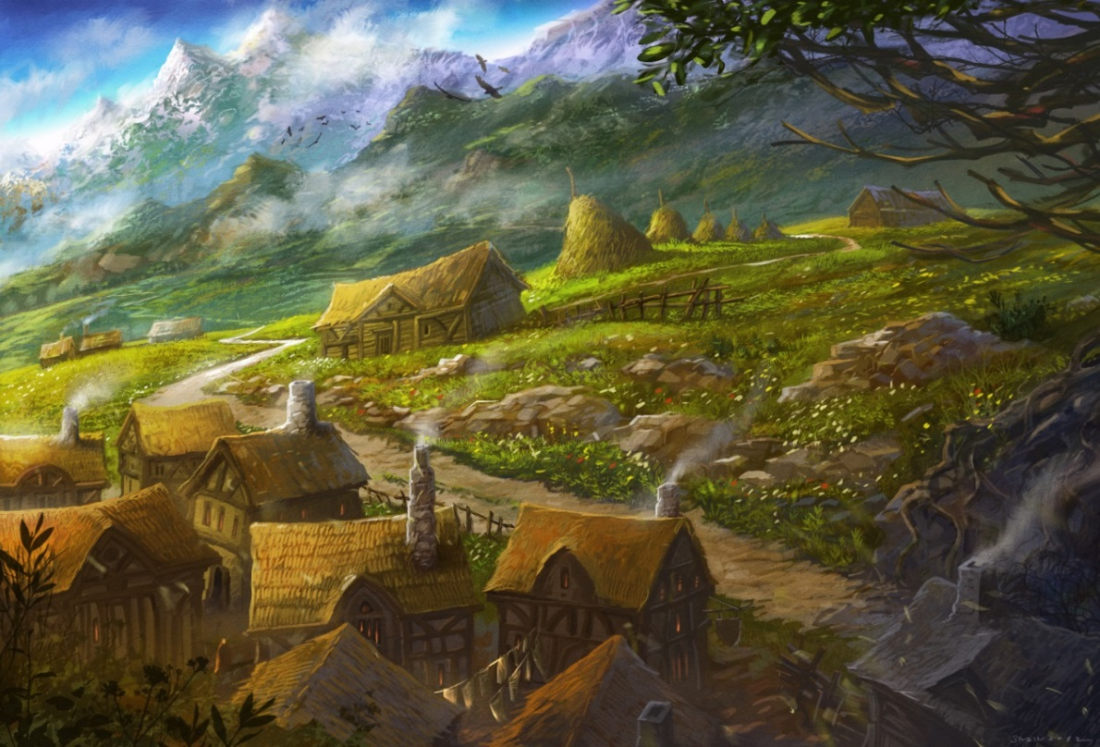
Valdarn
Races – Orcs/Humans
Deity – Tempus – God of War – Holy City - Brean
Loviatar – Goddess of Pain – Holy City – Farpoint
Capital - Brean
Institutions – Fighting Pits, War College - Algese
Along the Diamond Coasts, lies the clans of Valdarn. The Orcs of this land test their might in battles; for real and for the entertainment of all the kingdoms. This land is built upon the fighting pits of Stonebeard and the schools of training that help to supply all the various fighting pits through the kingdom. While not normal to most kingdoms, a noble family of Humans helps to run these schools in order for the Orcs to deal with the only true callings, that of battle and war.
Houses – Green - Fearbearer, Red - Redblade, Pale - Stonebreaker, Blue - Rainstomp, Human – Steelblood(Fighting Pits)

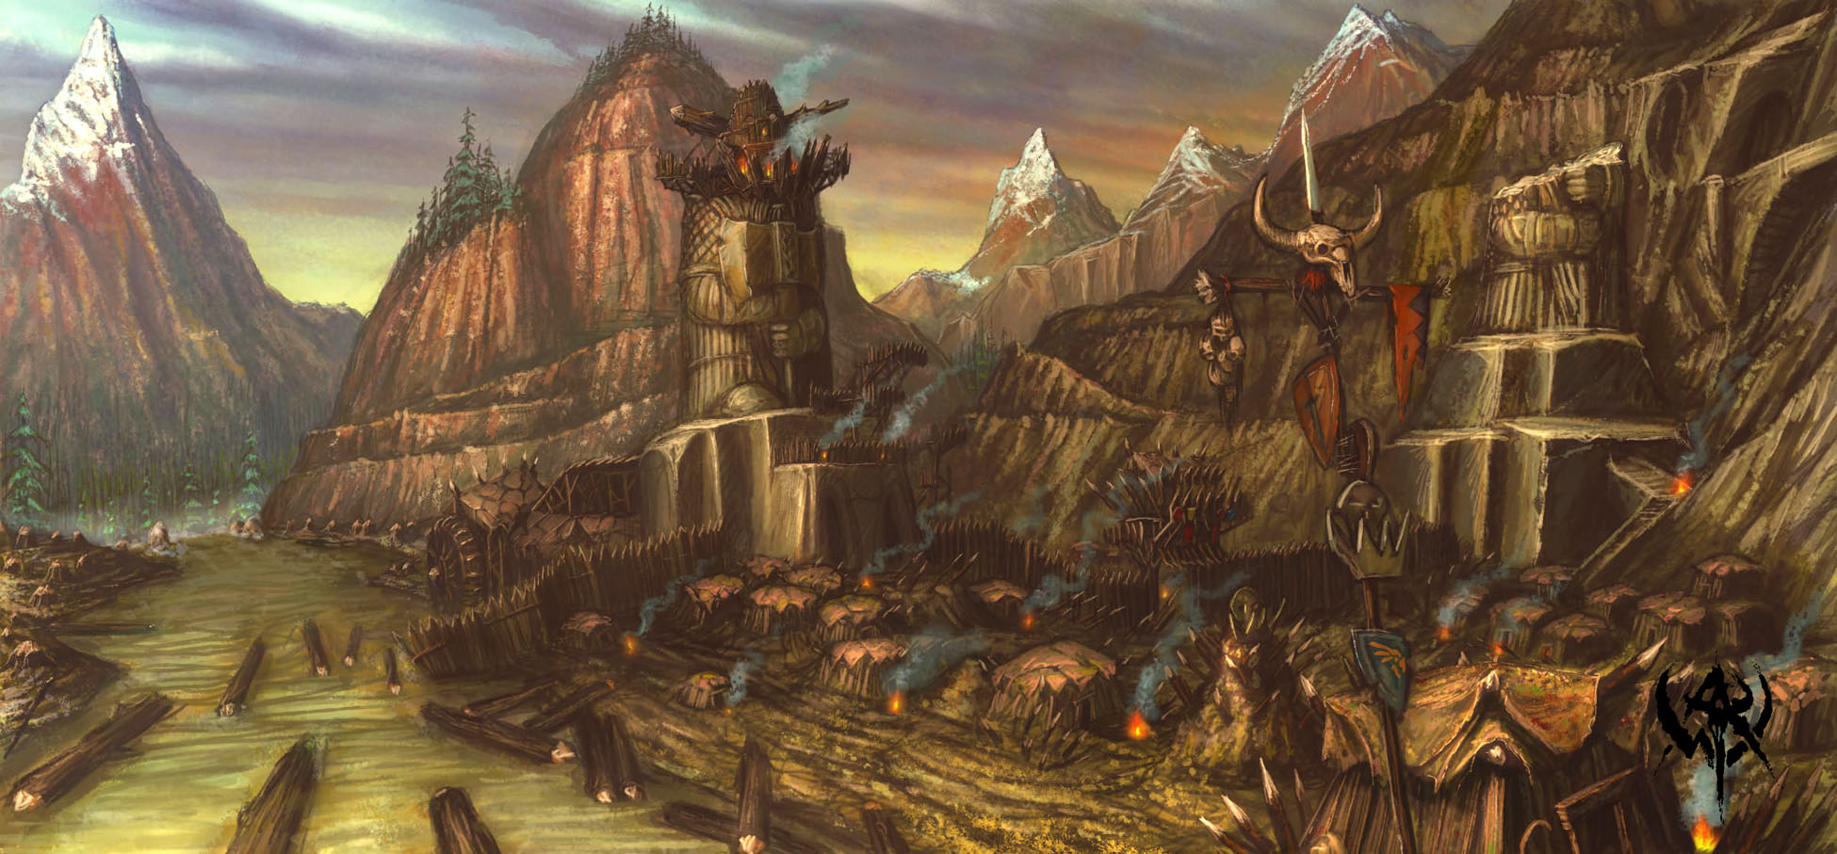
Kartaren
Races – Shifters
Deity – Raven Queen – Goddess of Death – Holy City - Adaren
Selune – Goddess of the Moon – Holy City - Kartar
Capital – Kartar
Institutions – Imperial Tombs – Avaranth, Society of the Bloodhunter - Vast
The lands of Kartaren are home to the Shifters. A race that have been the Royal guards since the founding of the empire. The whole kingdom sees it as the highest honor for any people to be selected by their “Captain”, the leader of the Shifters. Each member’s name is based upon their place of birth. The Tombs of all Emperors are built and guarded here for all eternity by the Shifters. The land is also home to the secret, yet well trained Order of the Bloodhunters, the Monstertrackers of the Empire, hunting down all banes to the world who would cause it ill. Little is known of them, but their skill is unquestioned.
Houses – Beasthide – Of the Plains, Cliffwalk – Of the Rocks, Longstride – Of the Grass, Longtooth – Of the Mountains, Razorclaw – of the Hills, Wildhunt – Of the Woods
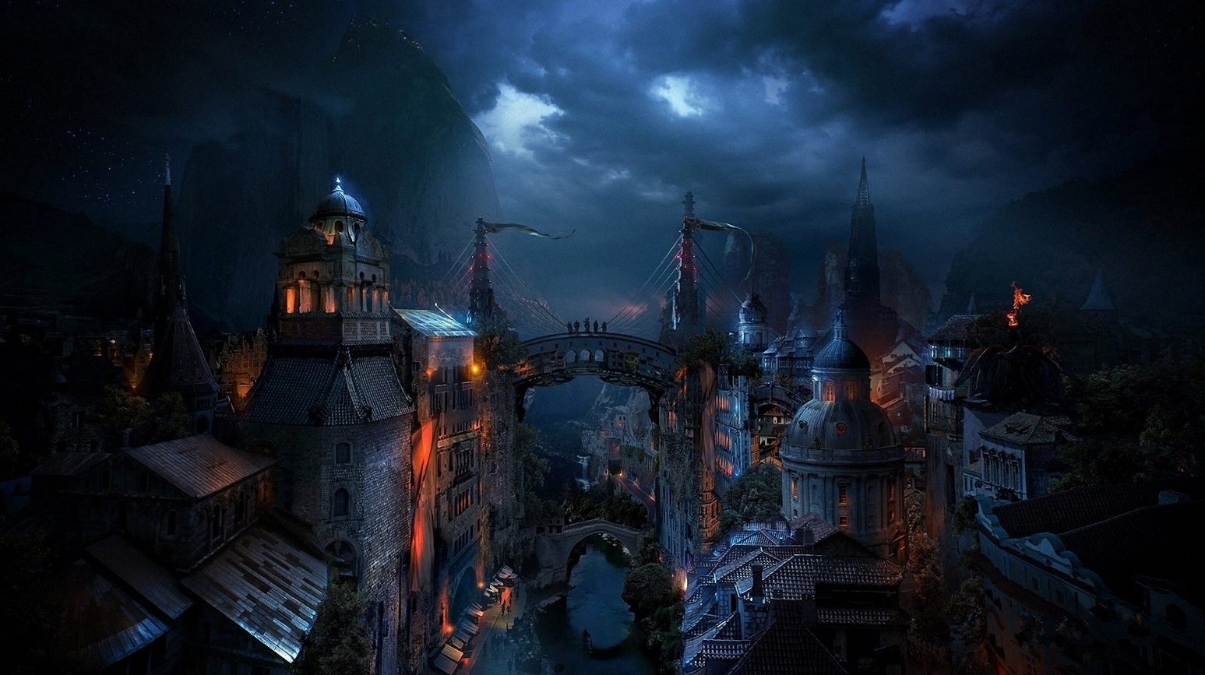
Nordavind
Races – Goliaths/Half-Giants
Deity – Auril –Goddess of Winter – Holy City - Dunmere
Talos – God of Storms – Holy City - Meremar
Capital - Dunmere
Institutions – Barbarian Proving Grounds - Icegate
The Great Herds of the Goliaths and Half-Giants roam and populate this harsh land, most calling it the “Top of the World.” While most just wish to be left to their own culture, anyone is welcome to come and try to prove themselves to the herd for membership and training in the baser instincts of people. When someone is ready for the Proving Ground, they a pitted against a senior member of their Herd to show they can handle themselves. These are days where either one comes out as a true warrior of the world or food for the wolves. The Herd chieftains most meet to select proving ground combatants, however, a small group of elders, the Peakwalkers, deal with running the kingdom and Empire.
Houses - Thuliaga - Frost, Anakalathai - Hill, Elanithino - Stone, Kalagiano - Cloud, Katho-Olavi - Fire, Kolae-Gileana - Storm
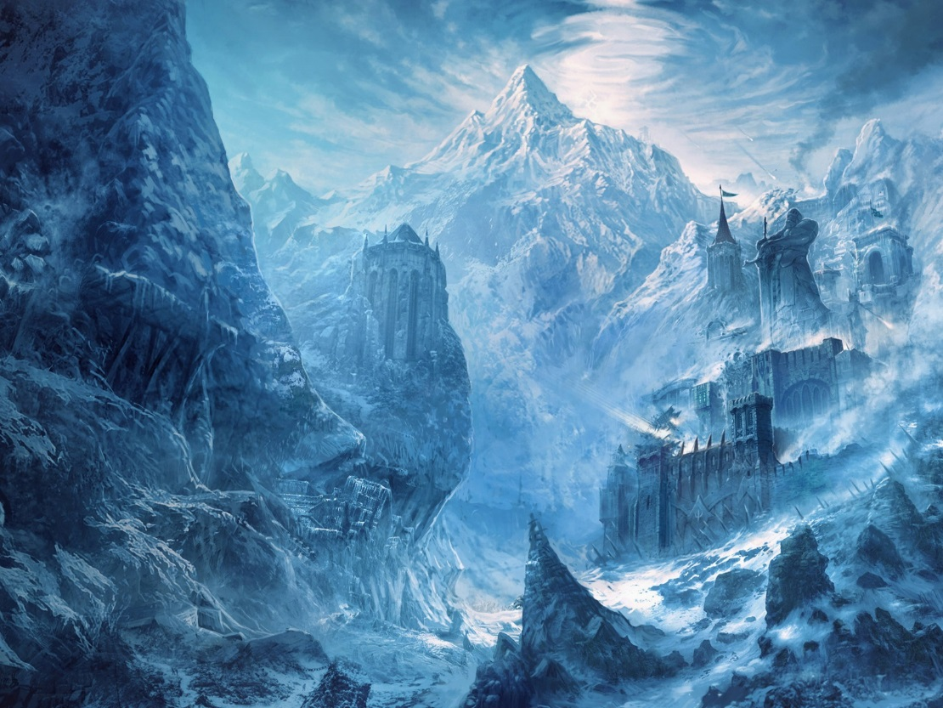
Laentas
Races – High Elves
Deity – Azuth – God of Wizards – Holy City - Brownstone
Oghma – God of Knowledge – Holy City - Damodar
Capital - Damodar
Institutions – Wizard school of the Magical Arts, Royal Library - Madrask
The Highly crafted cities of the high Elves show their talent in crafting and understanding of all forms of magic. All written works are sought out and added to the collection of the Royal Library. All of the Wizard schools train their new members in the ways of magic through knowledge rather than blood. Each house is ran by a Patron, who deals with the schools, the kingdom and the Empire. Each city looks completely different from the last, one in the clouds, another into a mountain to name a few.
Houses – Gaethil(ABJ), Vanmiel(CONJ), Rhuimiel(Enc), Kiendil(Ill), Ondoeth(Div), Haerina(Evo), Nightguard(Nec),Transdil(Trans)
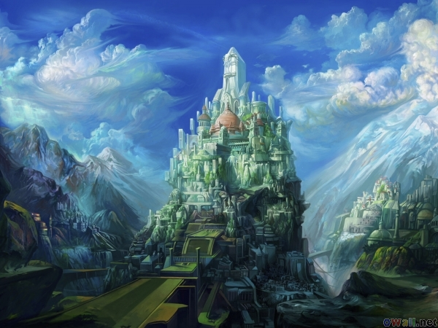
Faeland
Races – ½ races “Half-Breeds”
Deity – Bhaal – God of Murder – Holy City - Cliffside
Mask – God of Thieves – Holy City - Riordan
Umberlee – Goddess of the Sea – Holy City - Oberin
Lliira – Goddess of Joy – Holy City - Elerin
Capital - Elerin
Institutions – Thieves Guild – Rioradan, The Underground (Rogue training areas) -? , Sailors training - Oberin
The Home land of the First Queen of the Empire, Nordavind has long been a place where the other kingdoms sent the “half-breeds.” The product of couplings between different races. When a new child is born, they are brought to the Grand Home of Love, a place where all ½ children are brought to. The families of the kingdom are encouraged to visit at least twice in their lifetime and select a child for them to raise as their own. While couples can still have their own children, this is usually the way families get their children. Because of this dark beginning, there are rumors that schools of “less reputable” skills are located throughout the kingdom. This is also where the Sailors for ship are drilled in their craft.
Houses – Hahpet – ½ elf, Engong – ½ Orc, Stonehelm – ½ Dwarf, Overhill – ½ Halfling, Scaleborn – ½ Dragonborn
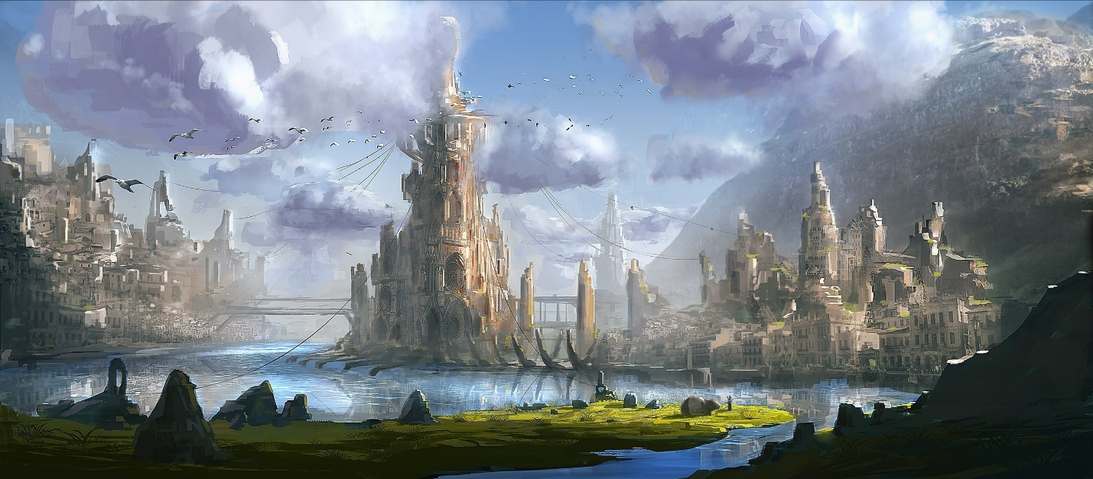
Kessen
Races – Gnomes
Deity – Gond – God of Craft – Holy City - Feldris
Deneir – God of Writing – Holy City - Nesos
Capital - Feldris
Institutions – Tinkers Guild – Feldris, Bookmakers Society - Nesos
The plains and mountains of Kessen are home to the heart of technology for the whole empire. Every race comes here to see the new creations, ideas and items crafted and invented by the ingenious Gnomes. While not all work on projects of metal and science, others craft amazing items of power and importance for all adventurers and people of the lands. Anything thought of has been tried here, some with success, other with failure and some….who knows. The Guilds that run this Empire do their best to keep research going, their skills at cover-ups are second only to their ingenuity.
House – Forest – Sliverglass(Tinker’s Guild), Rock – Titangill(Bookmaker’s Society), Deep - Blightsocket, Chaos – Mindbyte(Mapmaker’s Guild)
